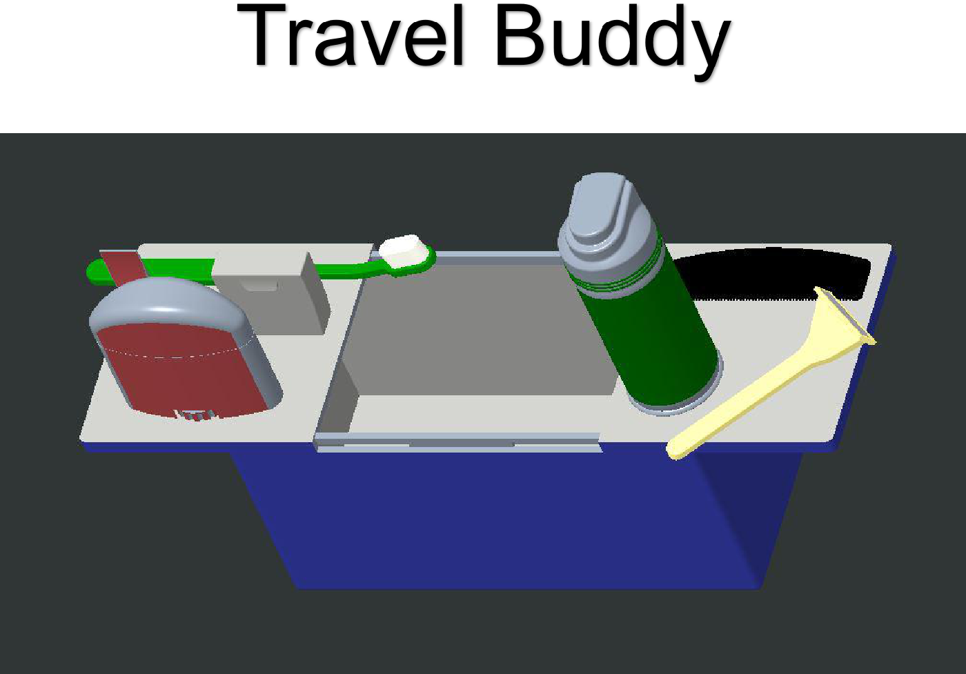

Personal travel hygiene kit

produced by RevBuddy

**1**



|  |  |  |
| --- | --- | --- |
| • | Before Use | 3 |
| • | Safety Considerations | 4 |
| • | Product Information | 5 |
| • | Warranty Information | 6 |
| • | Parts List | 7 |
| • | Detailed Product View | 8 |
| • | Contact Us | 9 |



1. Your Travel Buddy Ships already assembled .
2. Remove your Travel Buddy from plastic wrapping.
3. Inspect for any damage that may have occurred during shipping and ensure that the latch works properly.
4. Clean your Travel Buddy with hot soapy water, dry with a clean cloth, and allow to air dry until completely dry.



**3**



1. The Travel Buddy should be kept in a clean dry location.
2. If your Travel Buddy becomes cracked or broken, discard it and purchase a new one.
3. Broken pieces may cause a choking hazard to infants and young children.



4

Product Information

Your Travel Buddy is designed to be smaller than the standard issue military hygiene bag, making it a little larger than a mans shoe, but can still fin inside of a purse or a gym bag.

The lid on your Travel Buddy separates into two different pieces that are designed to be used as a stand for your hygiene products, supporting them about 4 inches off of the countertop.

The top of the lid and the inside of the Travel Buddy are white to allow the user to maintain cleanliness.

The Travel Buddy can be purchased in a variety of different colors and the case is made of plastic.

5

Warranty Information

The Travel Buddy comes with a full 90-day replacement warranty from the date of purchase. This warranty covers shipping damage or factory defects on your Travel Buddy hygiene bag. To receive a new product using the warranty simply file a claim on the website and ship the old product back. (website can be found on the “contact us” page)

6

Parts List

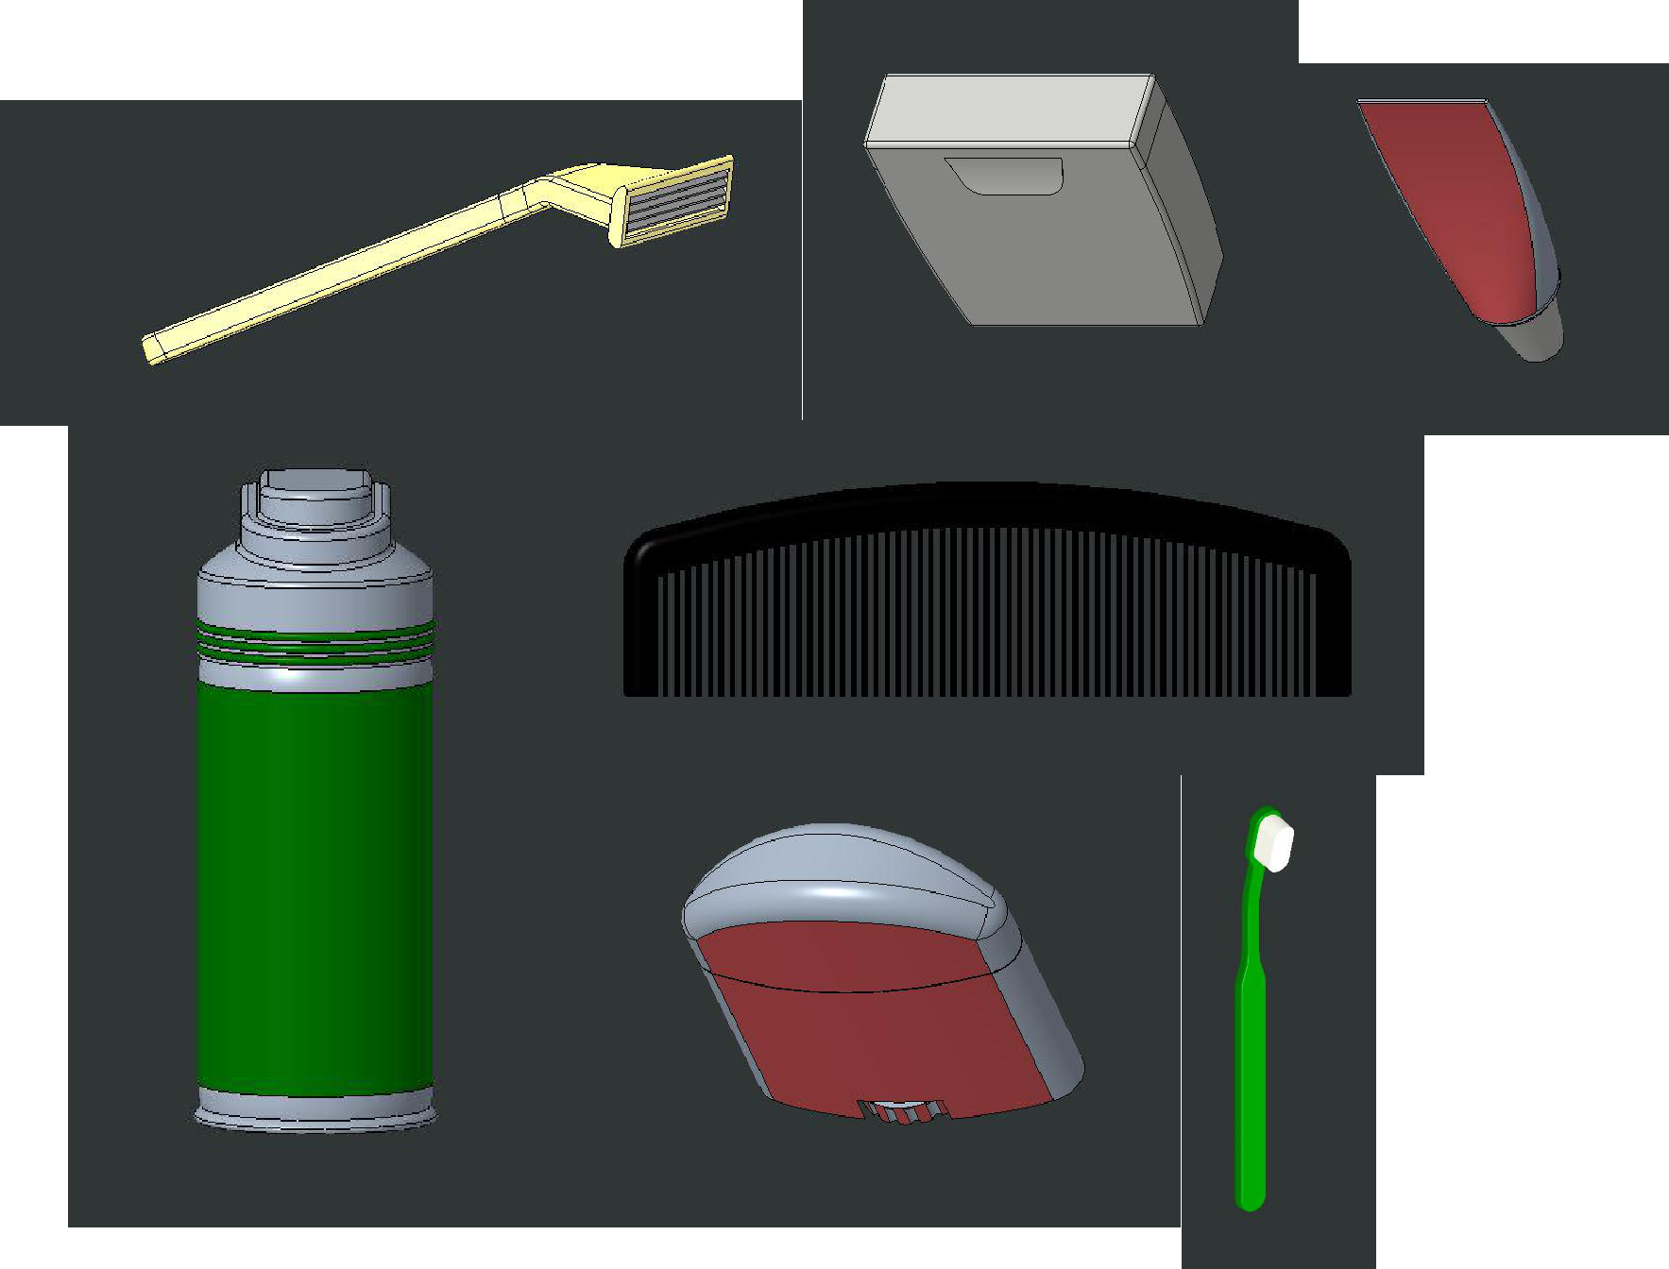

1. Comb
2. Deodorant
3. Floss
4. Razor
5. Shaving Cream
6. Toothbrush
7. Toothpaste
8. Travel Buddy Box

7

Detailed Product View

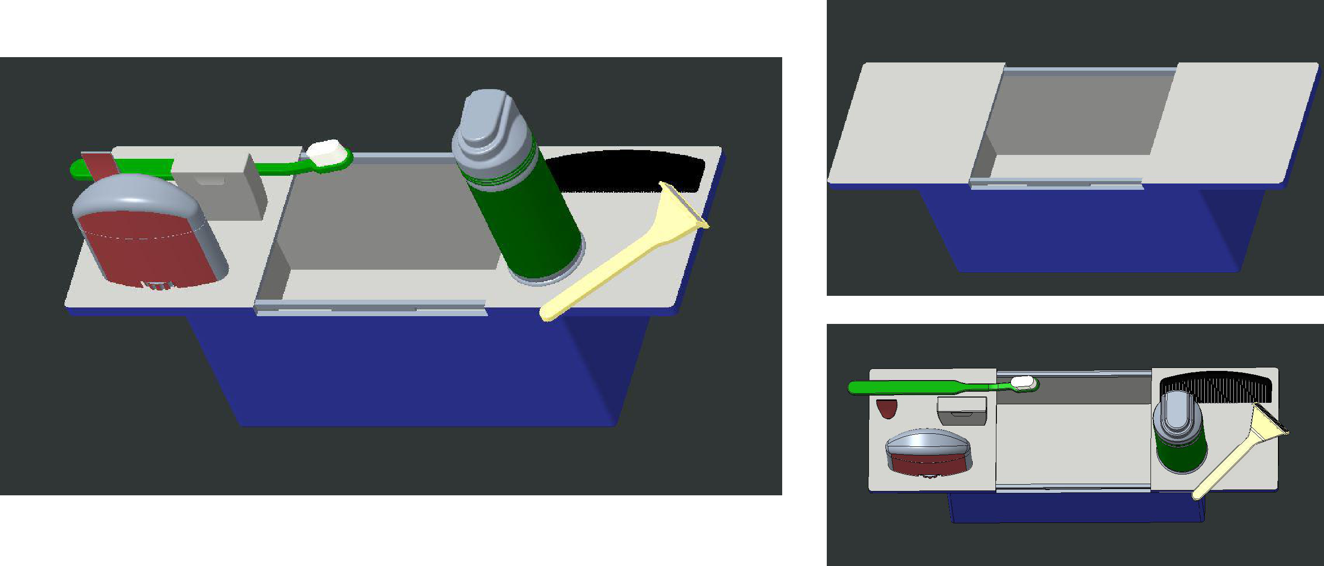

8

Contact Us

Thank you for your recent purchase on your Travel Buddy. We hope that you enjoy our product.

Our company website is:

https://webpages.uncc.edu/aspice10/index2.html

If you need to contact us directly we can be reached at:

Alexander Warpula - awarpula@uncc.edu

Lauren Passio - lpassio@uncc.edu

Ashley Spicer - aspice10@uncc.edu

Erik Pozorski - epozorsk@uncc.edu

9